
Year 8

Mini Test 6

Data and Statistics

Total Marks: 23 marks
Name: ______________________ Total Time: 25 minutes

Show working and answers on this sheet. Show working in sufficient detail to support your answers. Incorrect answers without supporting reasoning may be allocated zero marks.
Resources Allowed: 1 page A4 notes (1 side).

Question 1 4 marks

Complete the following sentences by using the following words. Note: there are more words than gaps. Census, sampling, median, mode, mean, outliers, range.

a) A ________________ is when data is collected from everyone within a group.

b) The __________ and ____________ are measures of the centre of the data.

c) _____________ can also be called the average.

Question 2 3 marks
What type of data are the following?
Choose from categorical, discrete numerical or continuous numerical:

- the number of hours spent playing video games each week ____________________

- the favourite pizza topping of each of the students in a class _____________________

- the length of time that a year 8 student can spend running ____________________

Question 3 3 marks
Mason wants to know which class is preferred by Baldivis Secondary College students, so he interviews 5 Year 7 students. Three of the Year 7’s interviewed say Maths is their favourite class and the other two say English. Mason’s conclusion is that Math is the most preferred class and English is the second most preferred class at the school.
- Is this a sample or a census? Why?

- How is this survey biased State one improvement that could be made to decrease the bias.

Question 4 3 marks
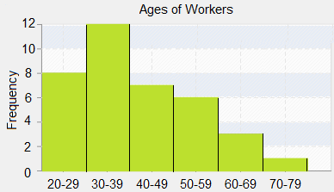
a) Would you describe the shape as symmetrical or skewed?

b) How many workers were over the age of 60?

c) How many workers were interviewed in total?

Question 5 10 marks

Consider the following set of data
73, 57, 73, 62, 20, 69, 62, 73, 65, 67, 70, 59, 71

- Draw a stem and leaf plot for this data.
b) Calculate;

Median

Mode

Mean

Range

c) Which score in the set of data is an outlier?

d) If the outlier is removed, what effect will this have on the;

Mean: _____________________ and Mode:_______________________

